# Task 3: Creating the Palette Configuration Model

A palette configuration model enables the users of Papyrus to define the tools in the palette of their UML profile editors.

There are two types of tools: 1) Creation Tools, which are used to create Nodes in the diagram; 2) Connection Tools, which are used to create edges that connect Nodes in the diagram.

The users are also able to create "drawers" in the palette, which they can group their creation tool in their preferences.

The metamodel of the palette configuration is shown below:

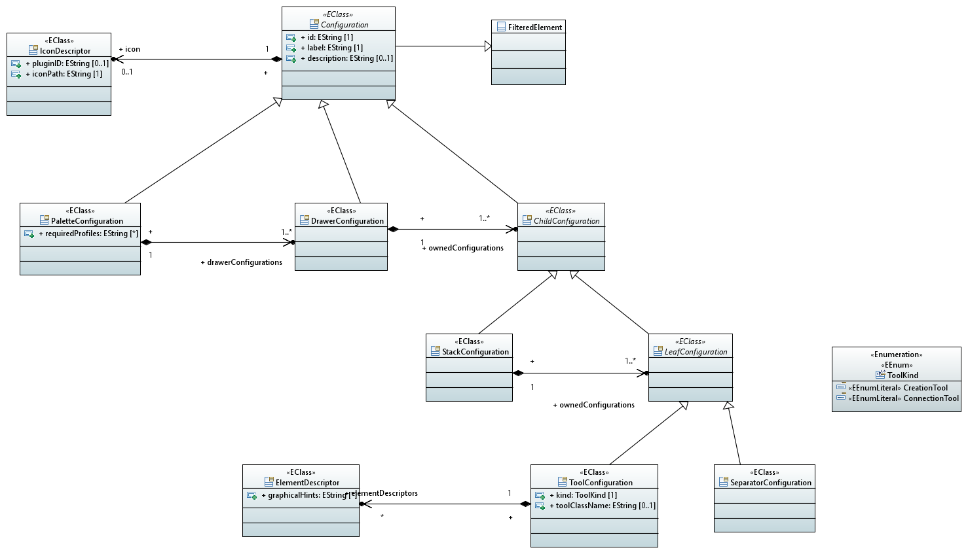

For your UML profile, define a Palette Configuration model, and for each Stereotypes defined in your profile, create its corresponding creation tool (Creation Tool/Edge Tool).

You will also need to relate to your Element Types Configuration model in the Palette Configuration model so that at runtime Papyrus is able to relate to the actual Stereotype when you use a creation/edge tool.

**Tasks:**

1. **Define the Creation tool for an arbitrary Stereotype for the Class meta-element.**
2. **Define the Connection tool for an arbitrary Stereotype for the Association meta-element.**
3. **If you find no problems with the previous tasks, define the palette in full.**

**Note: you have 30 minutes to complete this task.**